Nama : Martin Caesar Partogi

NPM : 242310034

TI-24-PA 2

Link Git HUB : <https://github.com/Martin-CaesarP/Desain_Analisis_Algoritma>

Tugas descending memakai metode bubble sort, insertion sort, dan selection sort.

1.

Bubble sort

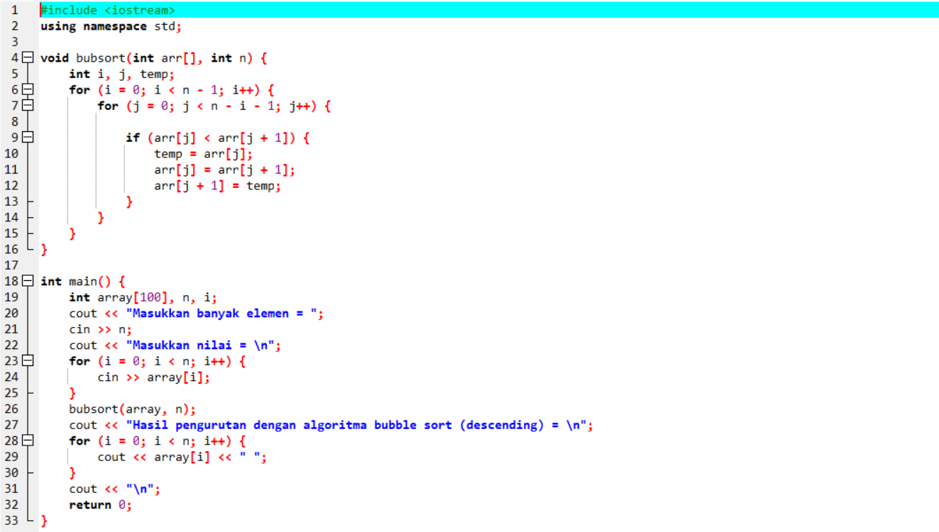

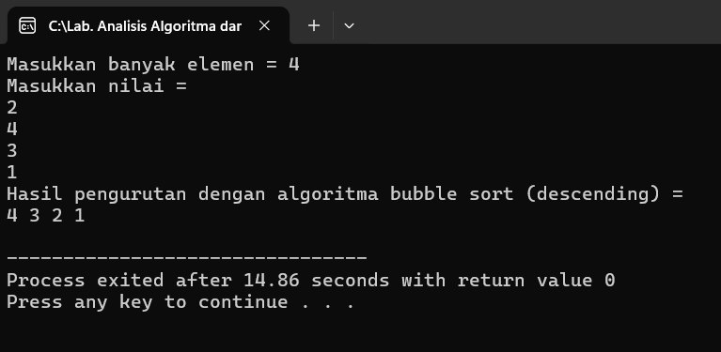

Insertion sort

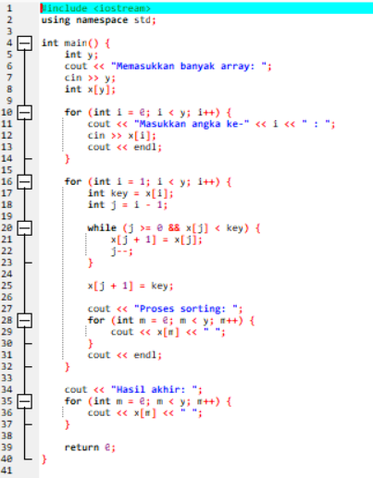

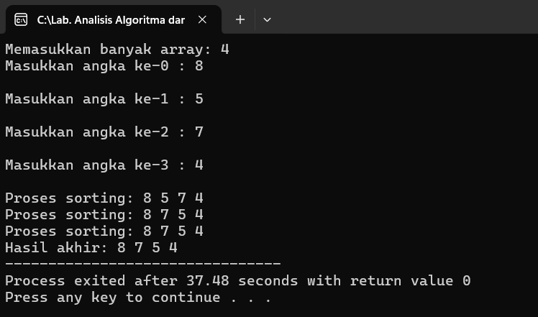

Selection sort

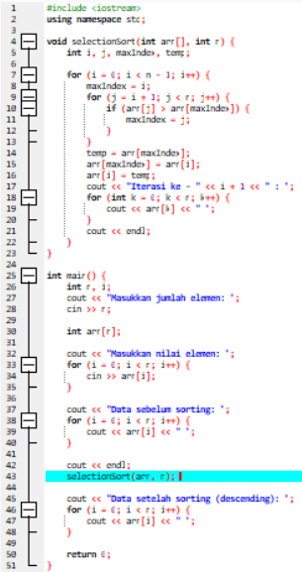

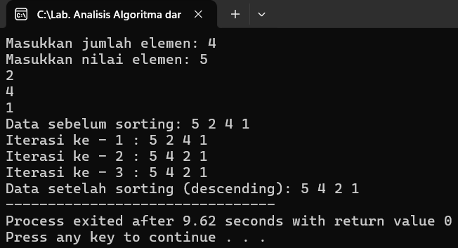

2.

Memakai metode Bubble sort

